**FLUTTER PROJECT**

**EVHUB - The Ultimate EV Companion App**

* EVHub is a mobile application designed to help users explore and navigate the world of electric vehicles (EVs).

**PROJECT SETUP:**

STEP 1: Page Creation

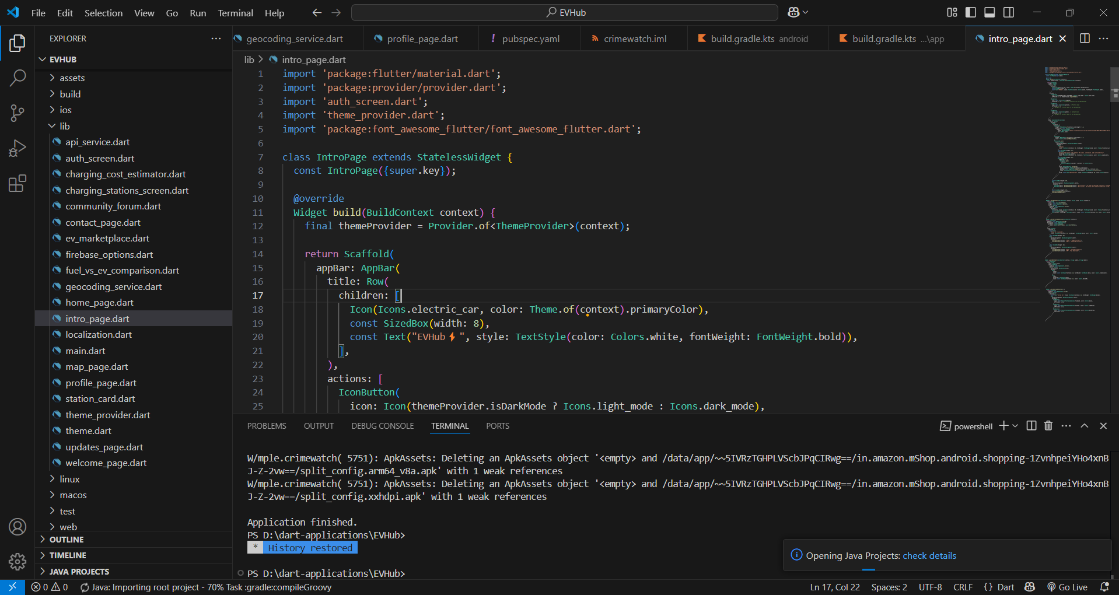

**STEP 2: Fetching API Key**

* API Key for Open Charge Map (Charging Stations)
* API Key for NewsAPI (EV News & Updates)

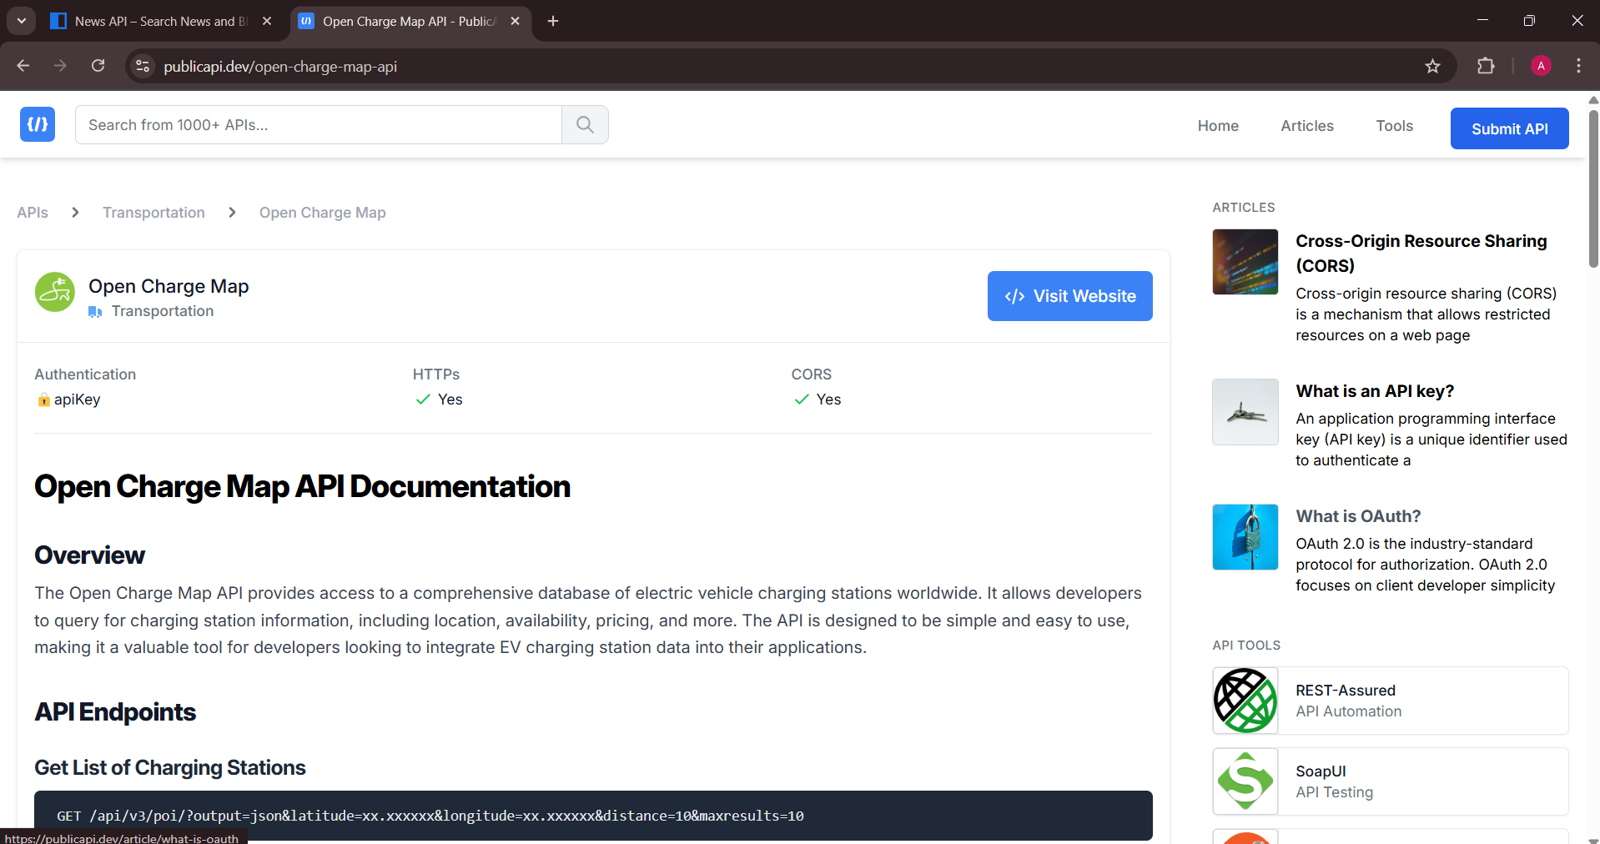

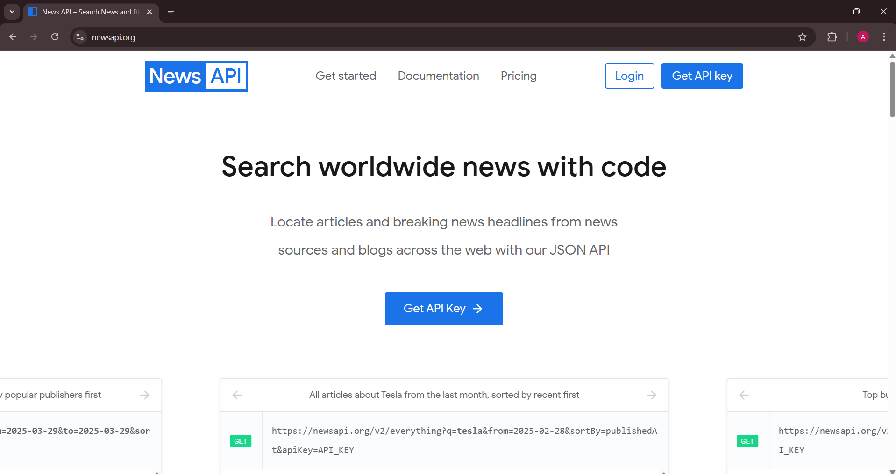

**STEP 3: Using JSON for dynamic loading in an EV Marketplace page**

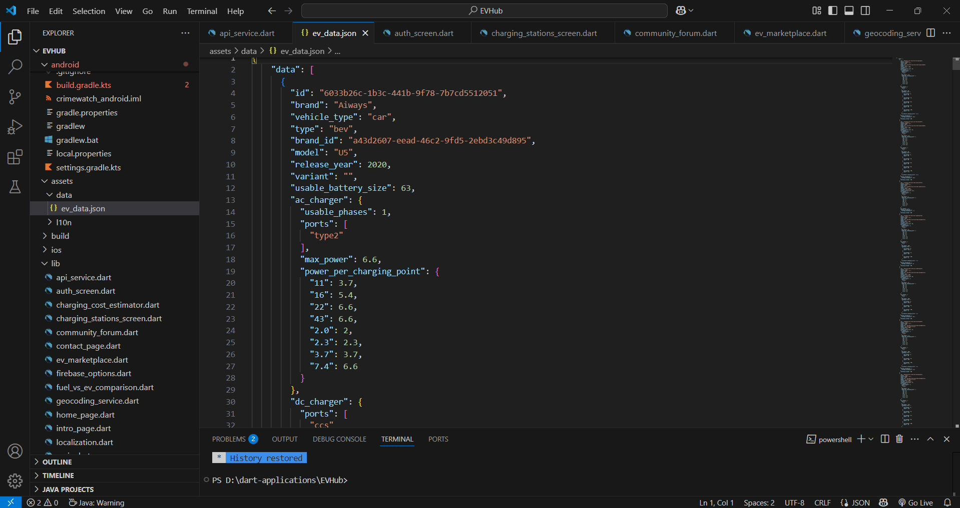

**STEP 4: Localization (Language-Support)**

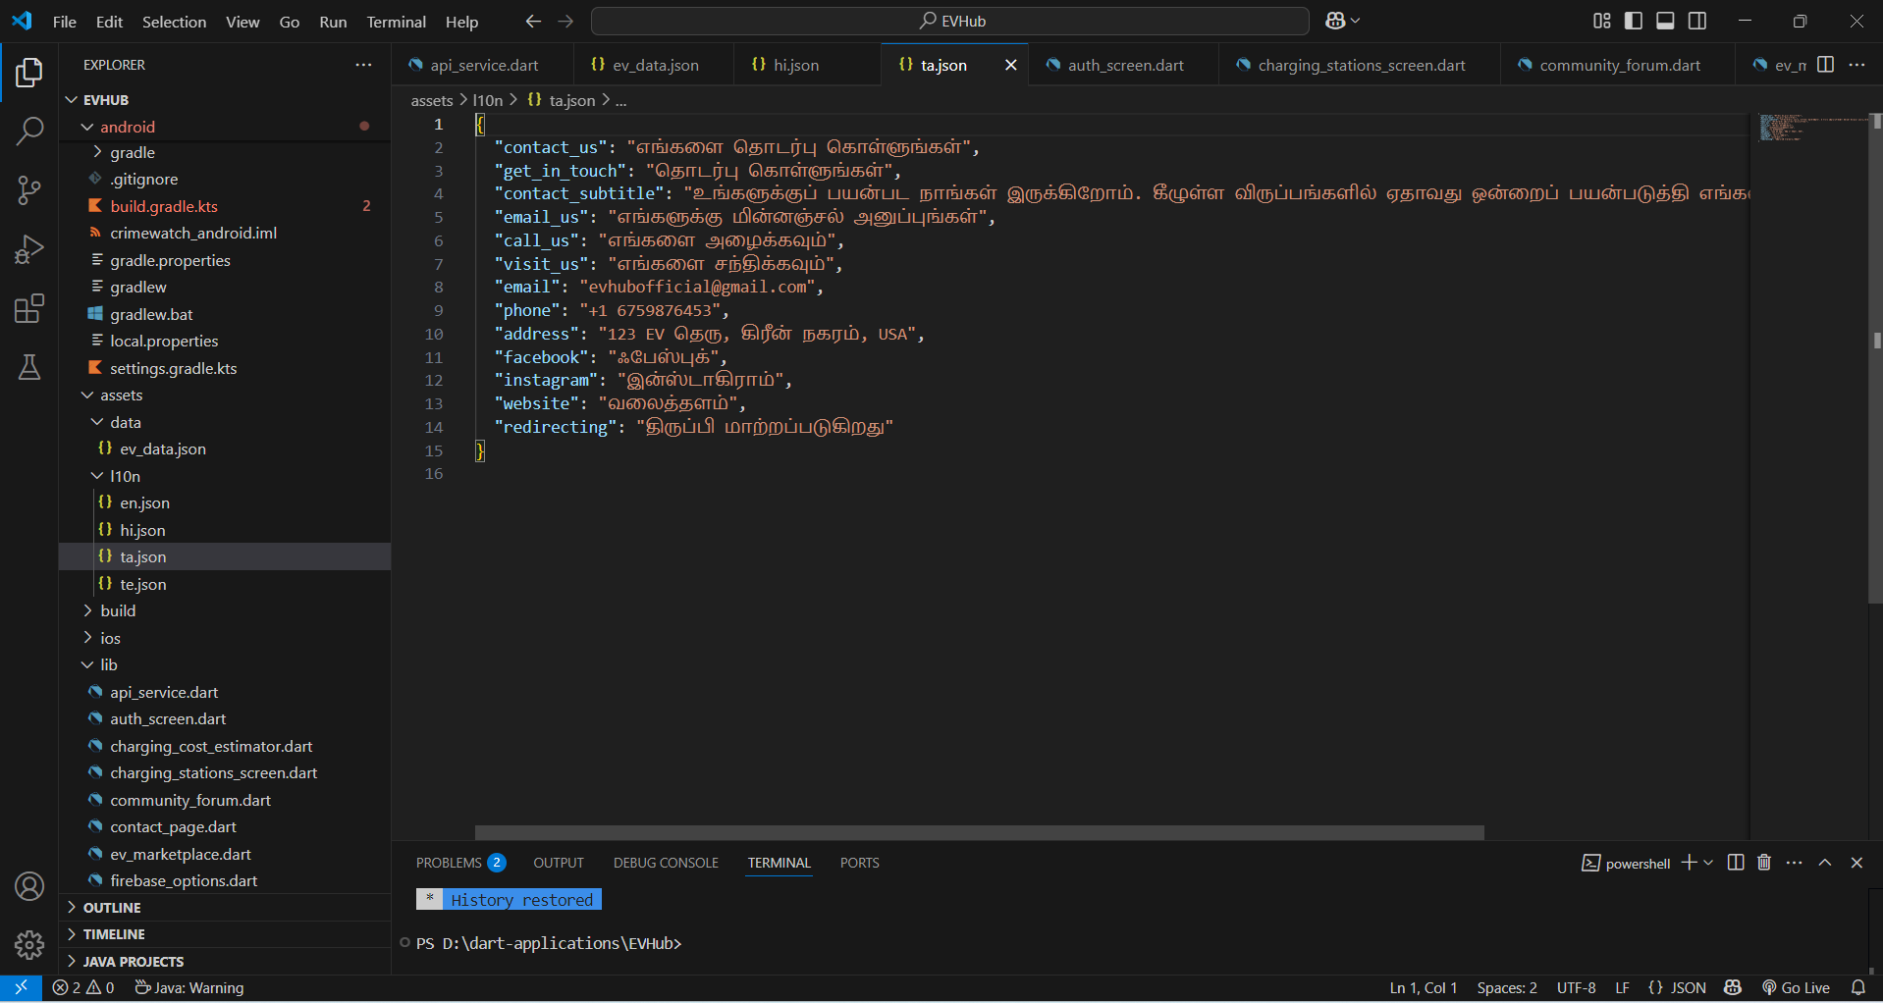

**STEP 5: Firebase Database**

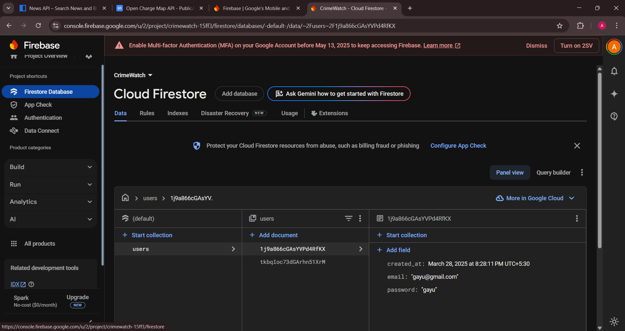

**STEP 6: Firebase Authentication**

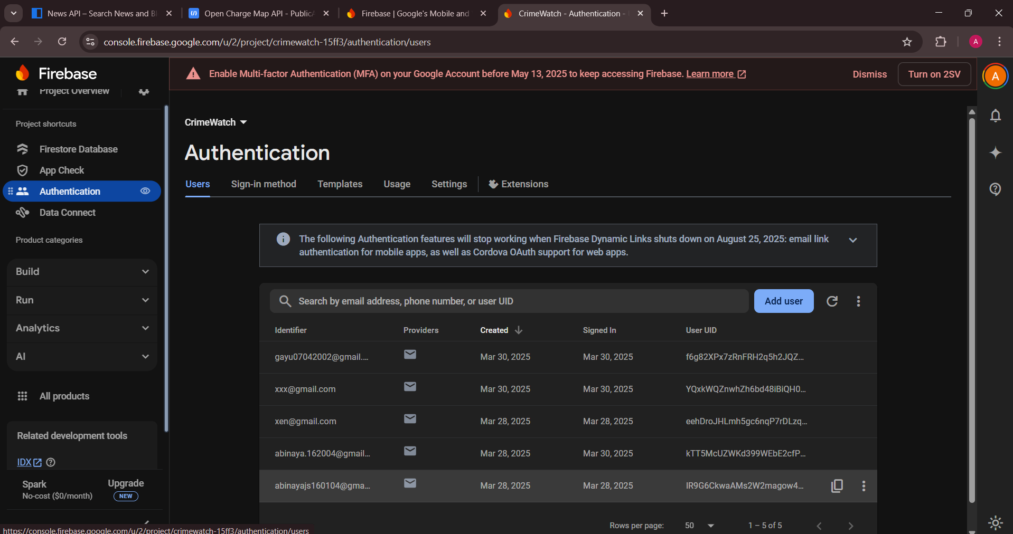

**STEP 7: Dependencies**

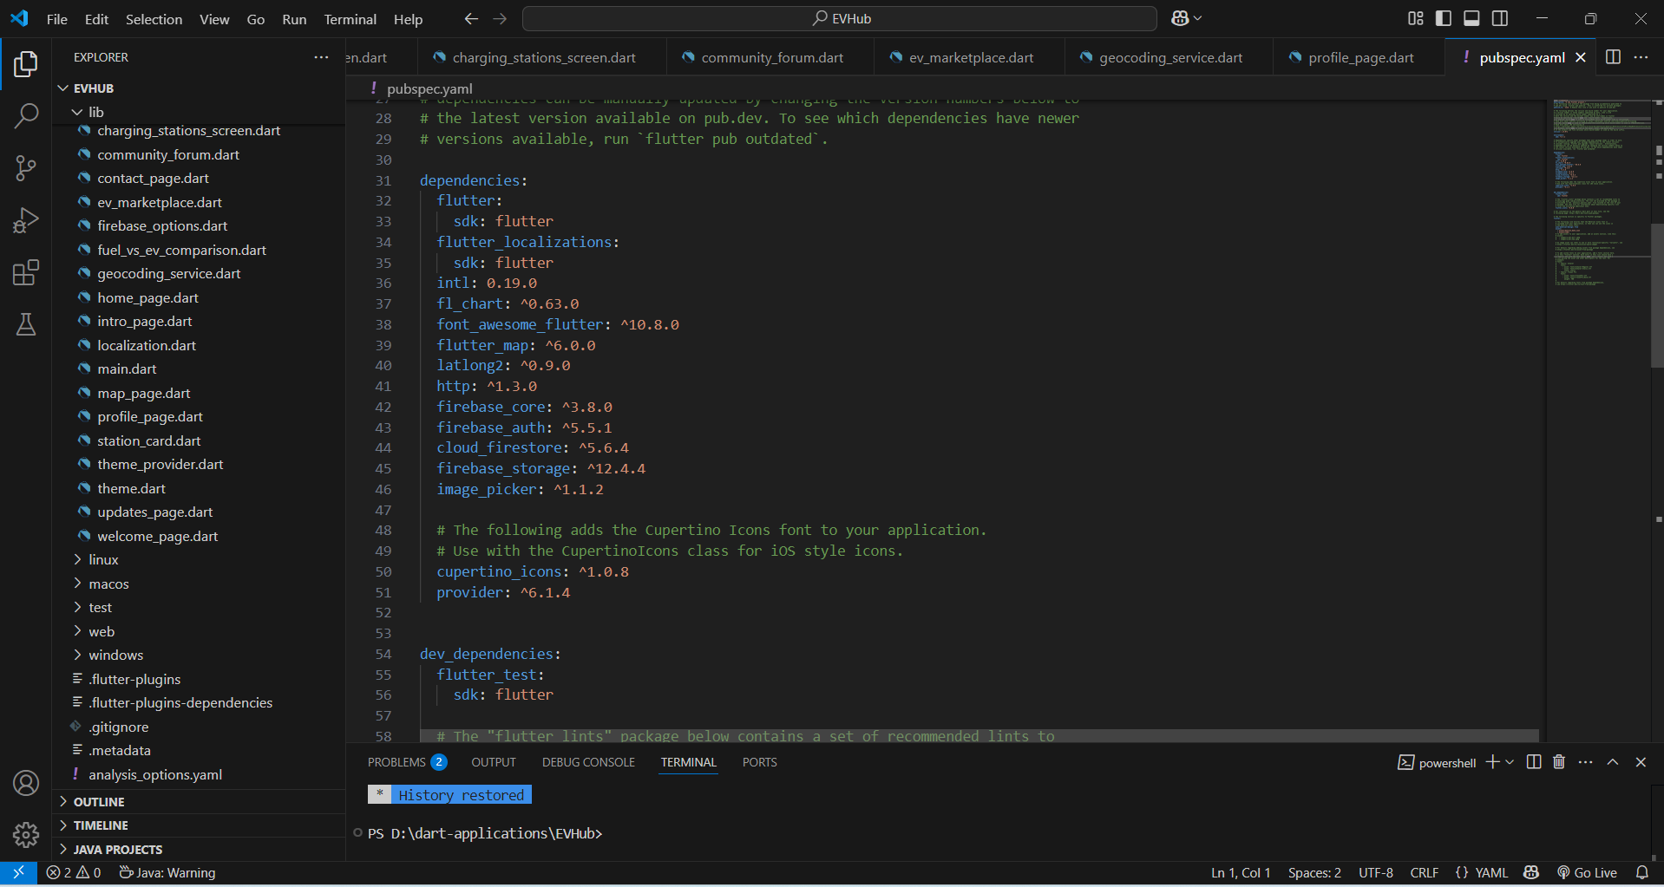

**OUTPUT:**

**NAVIGATION FLOW**

* **Welcome Page:**

Users are greeted with an intuitive interface to explore EVHub’s features.Upon tapping “Get Started”,navigates to login page

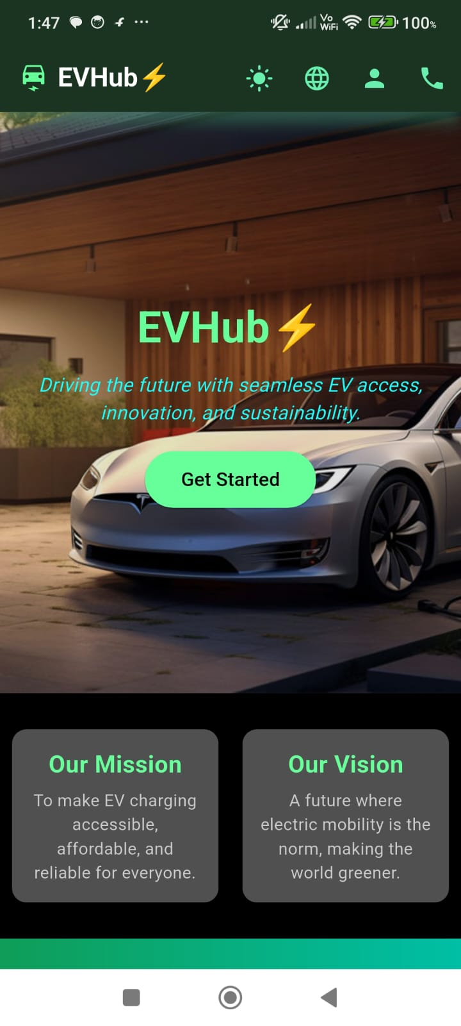

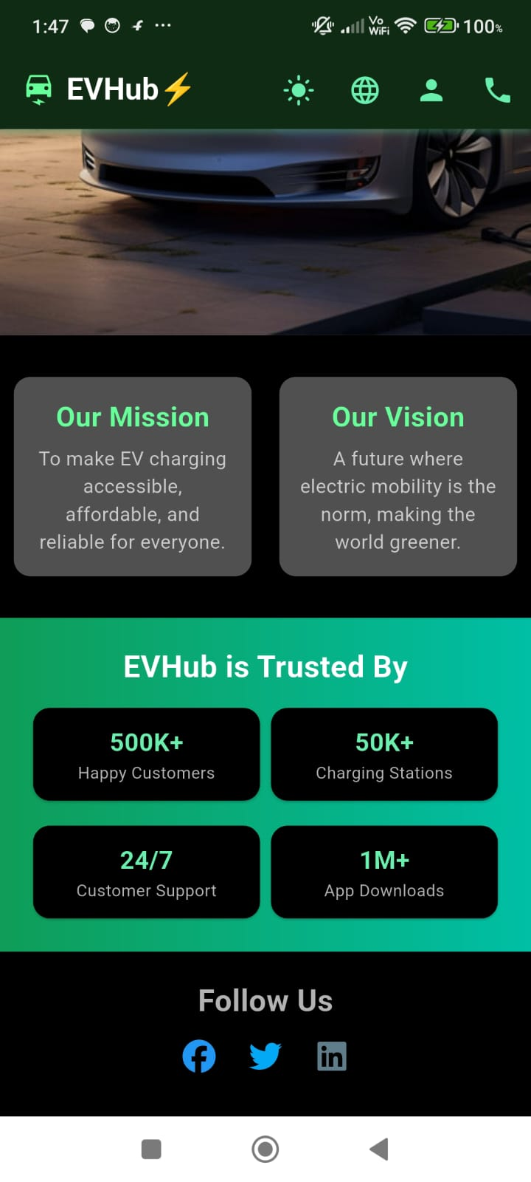

* **Login Page**

Users can register if they don’t have an account. Upon registration, credentials (email and password) are securely stored in Firebase. Existing users can log in to access the app**.**

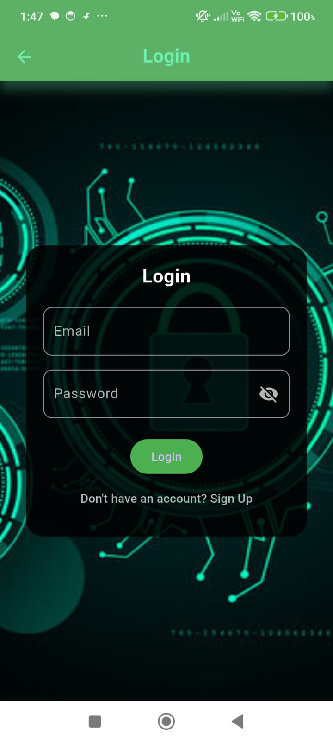

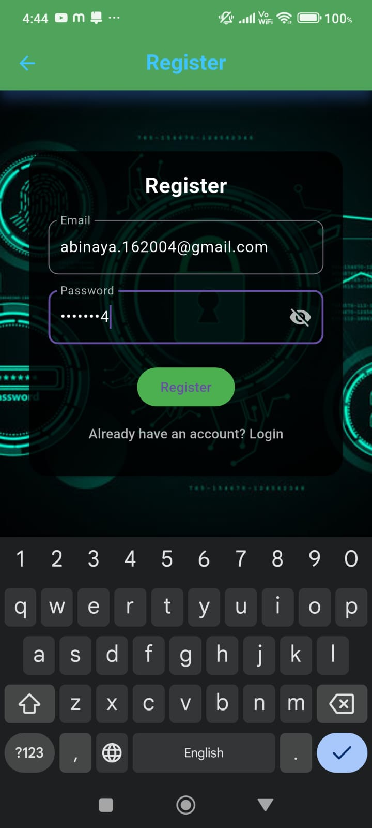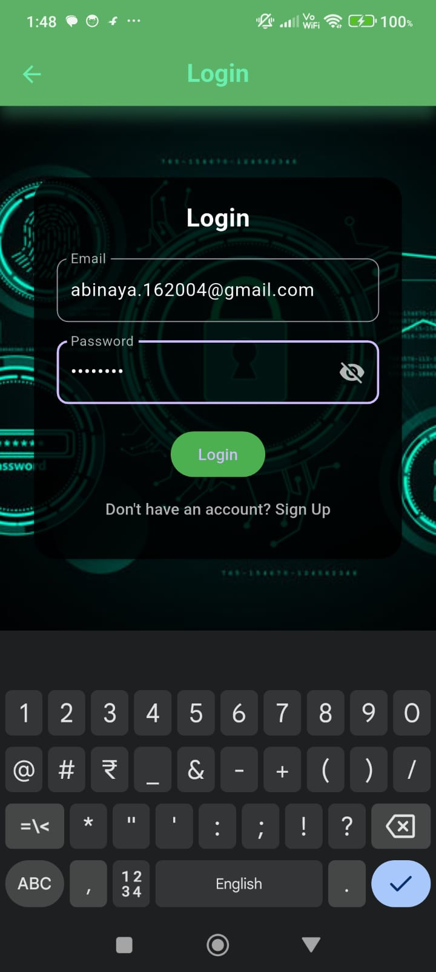

* **Home Page**

**Offers features like finding nearby charging stations, cost estimator, EV updates, a community forum, fuel vs EV comparison, and an EV marketplace.**

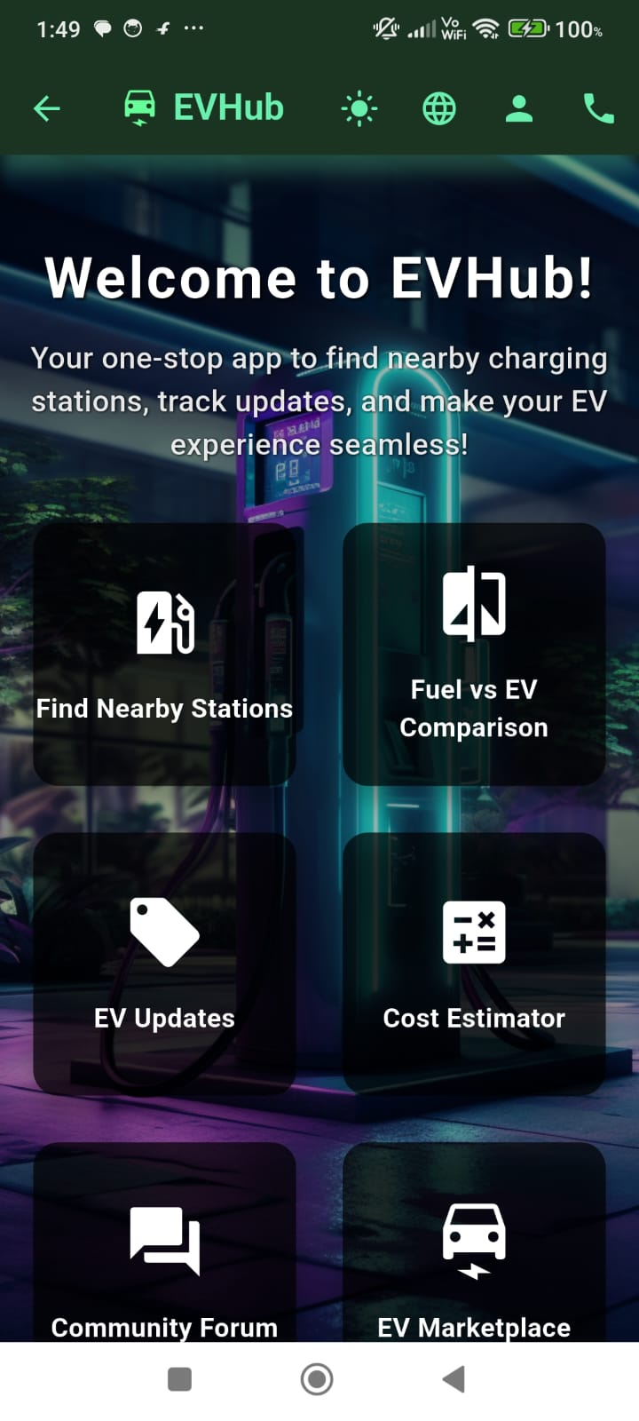

* **Charging Stations**

**Users can find nearby charging stations by entering their location, with real-time availability displayed. Tapping on a station shows its location on a map with a pin for easy navigation. Available globally in locations like Indonesia, China, Chennai, and Goa.**

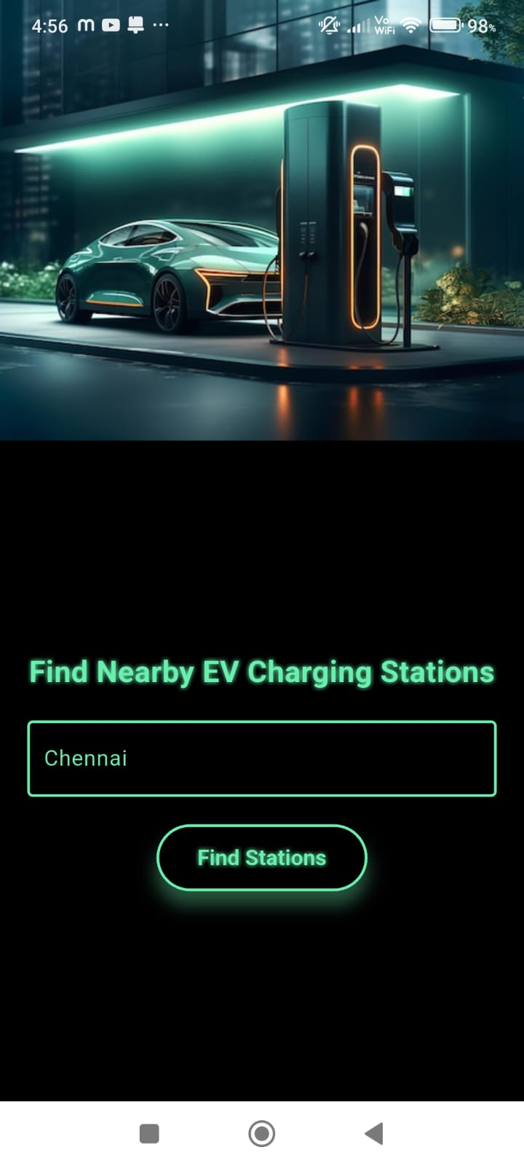

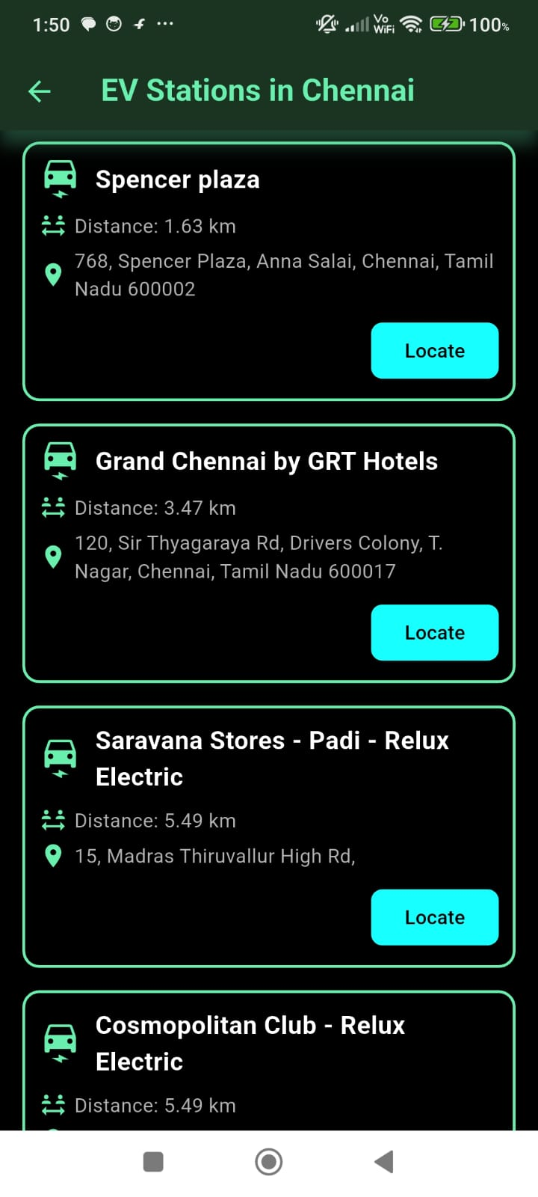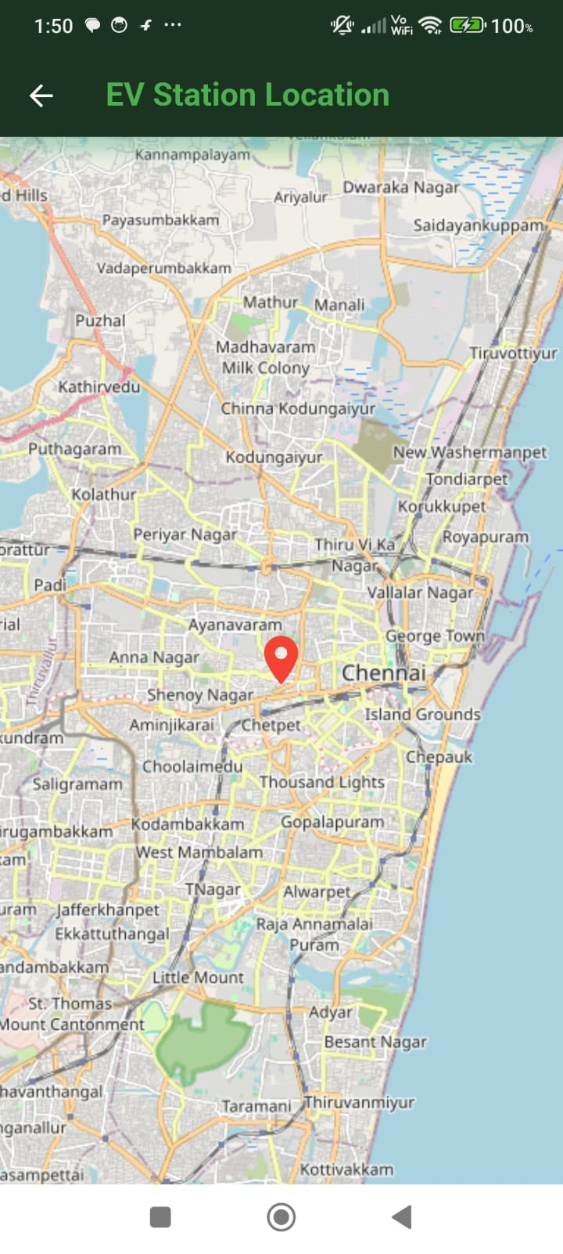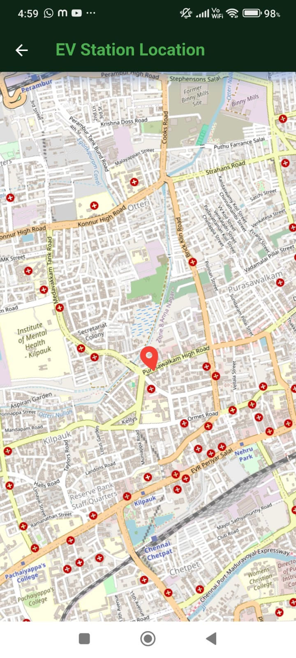

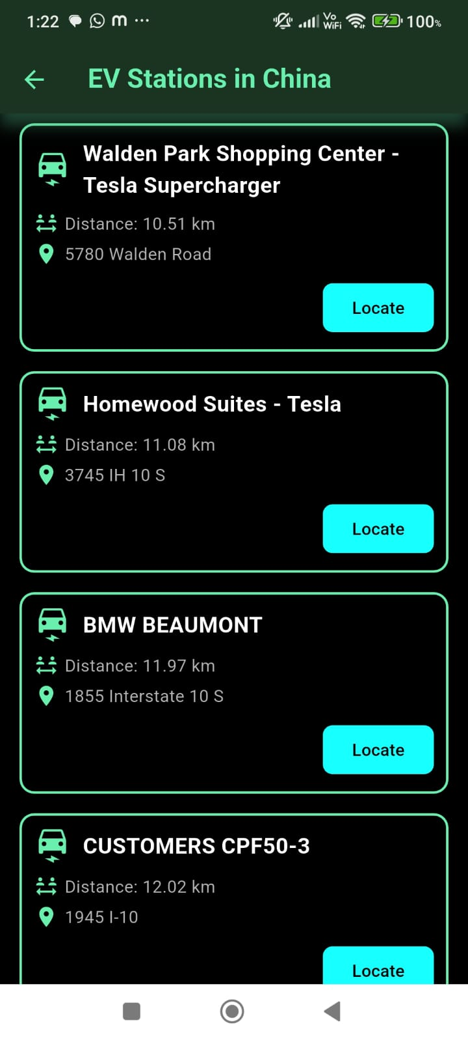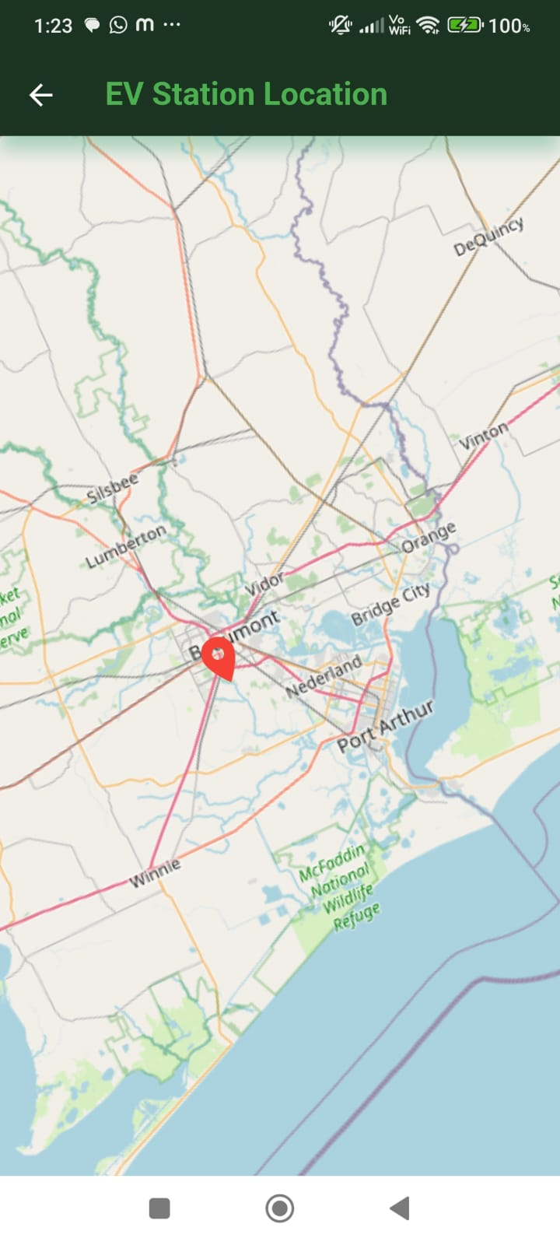

* **EV Updates**

**Provides the latest EV news, keeping users informed about new electric vehicle models, industry trends, and technological advancements.**

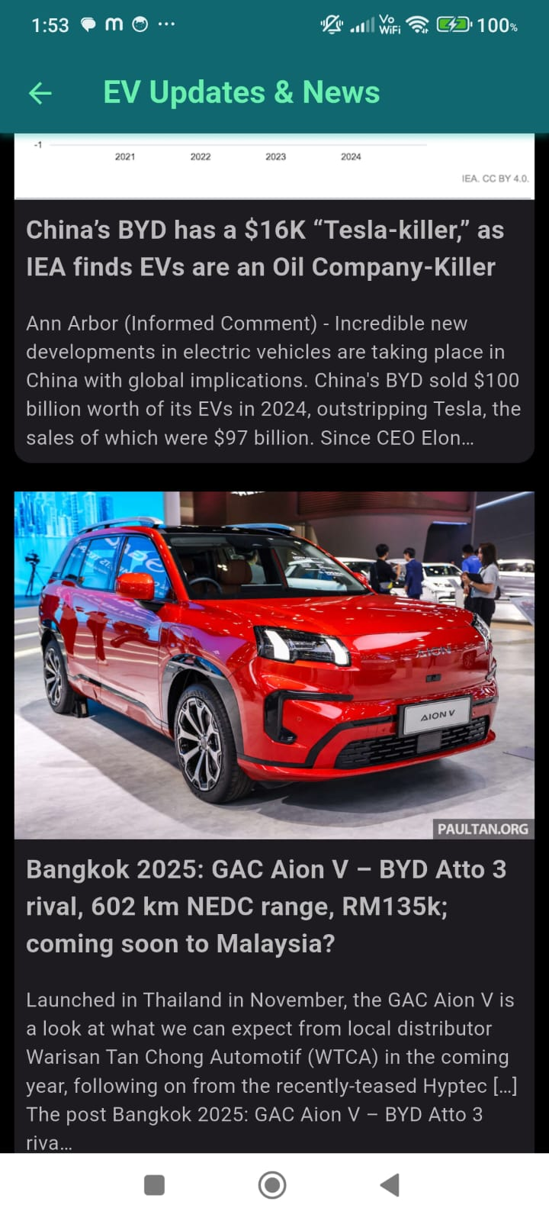

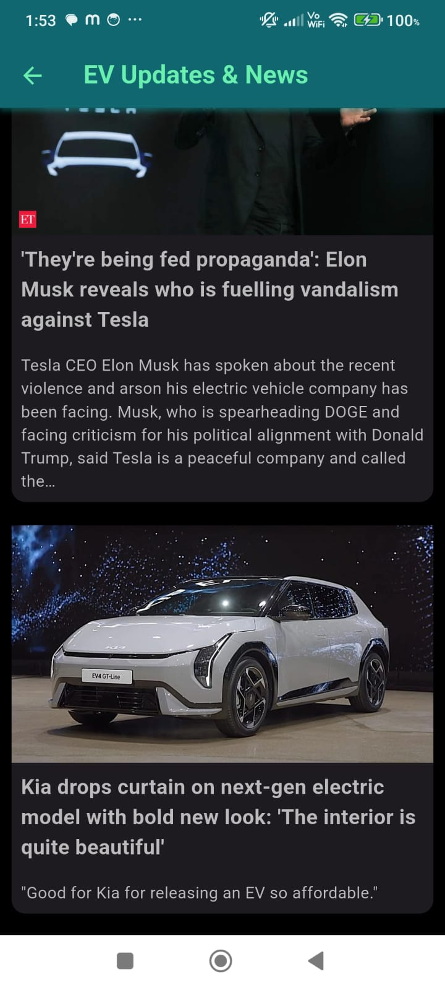

* **Cost Estimator**

**Estimate your EV costs and compare them with traditional fuel expenses.**

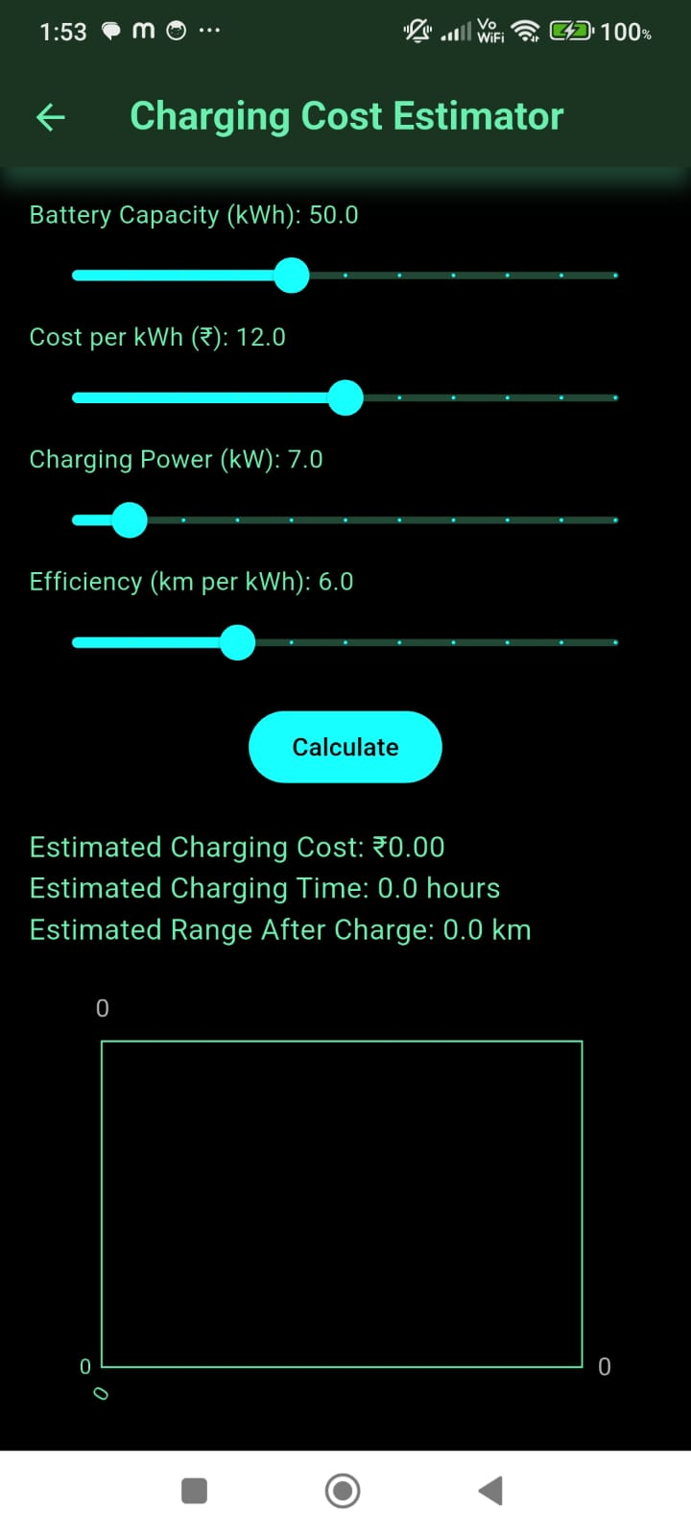

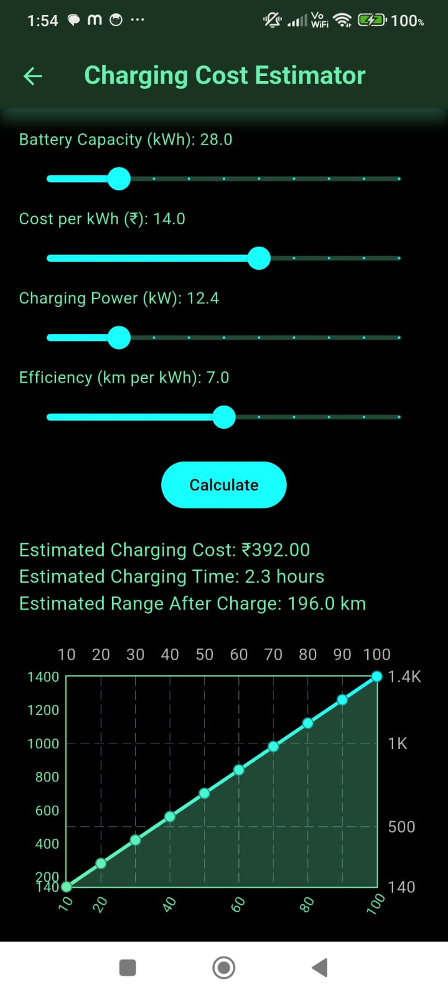

* **EV vs Fuel**

**Analyze efficiency, cost, and long-term benefits of EVs vs fuel-powered cars.**

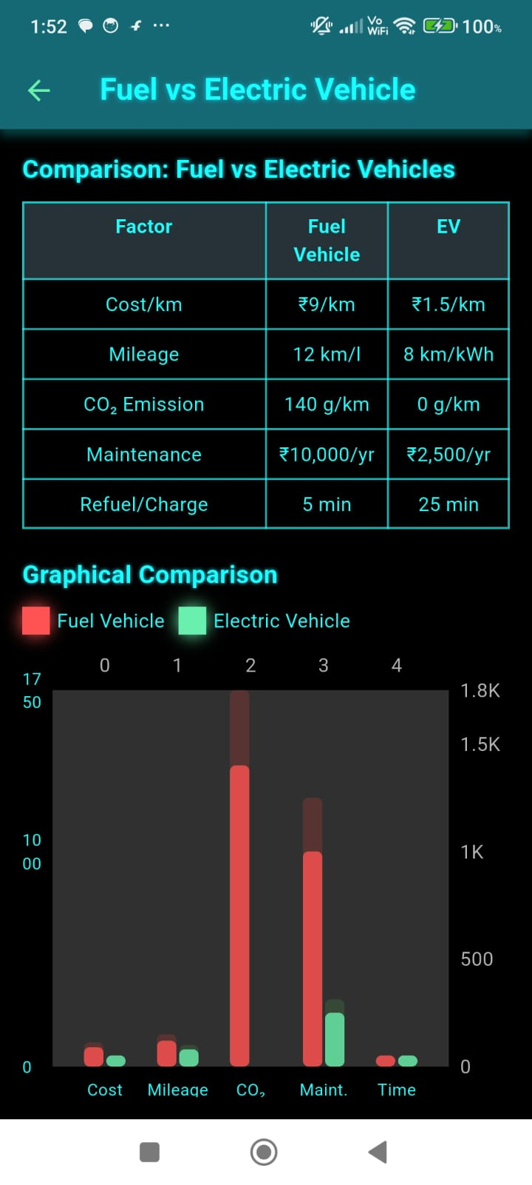

* **EV Marketplaces**

**Explore EV marketplaces to buy, sell, and compare vehicles.Also has search functionality so that users can search by model name year.**

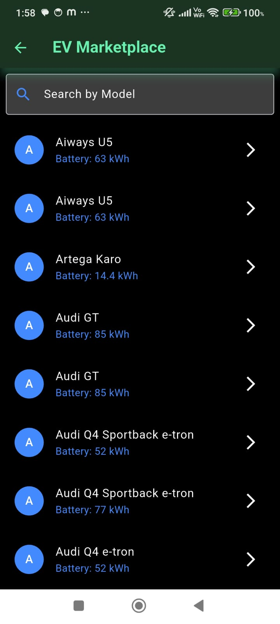

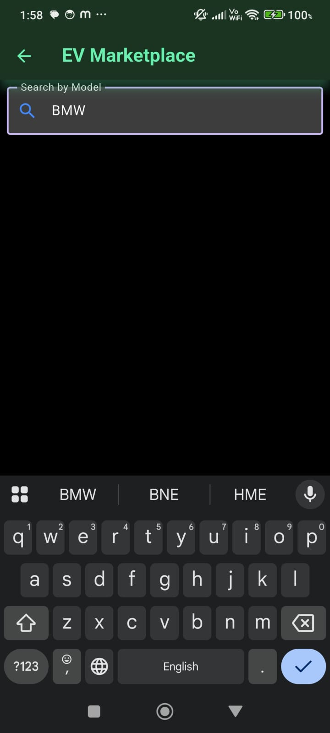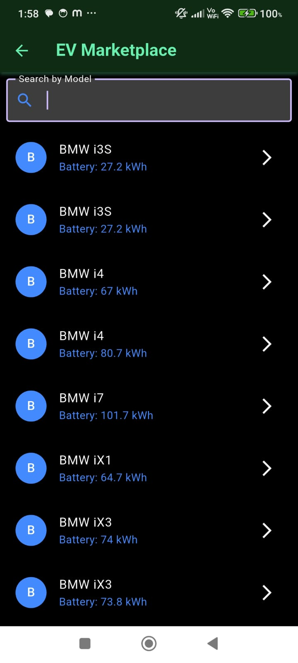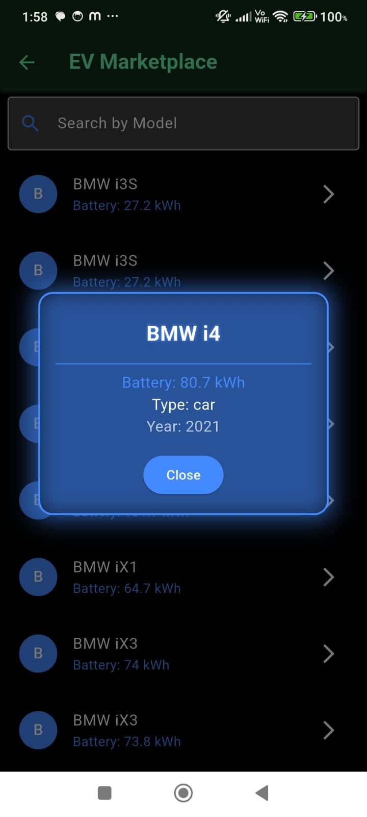

* **Community Forum**

**Join discussions, share experiences, and connect with EV users.**

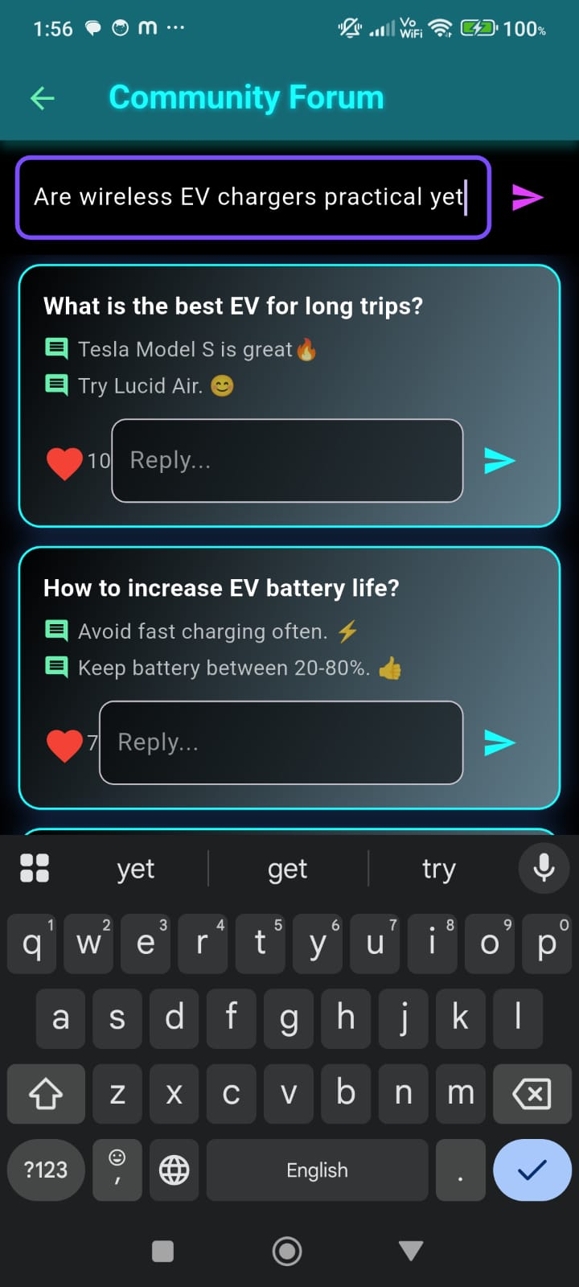

**APP-BAR ICON FUNCTIONALITY**

* **User Profile Management [Profile Icon]**

Manage your profile, preferences, and personalized settings.

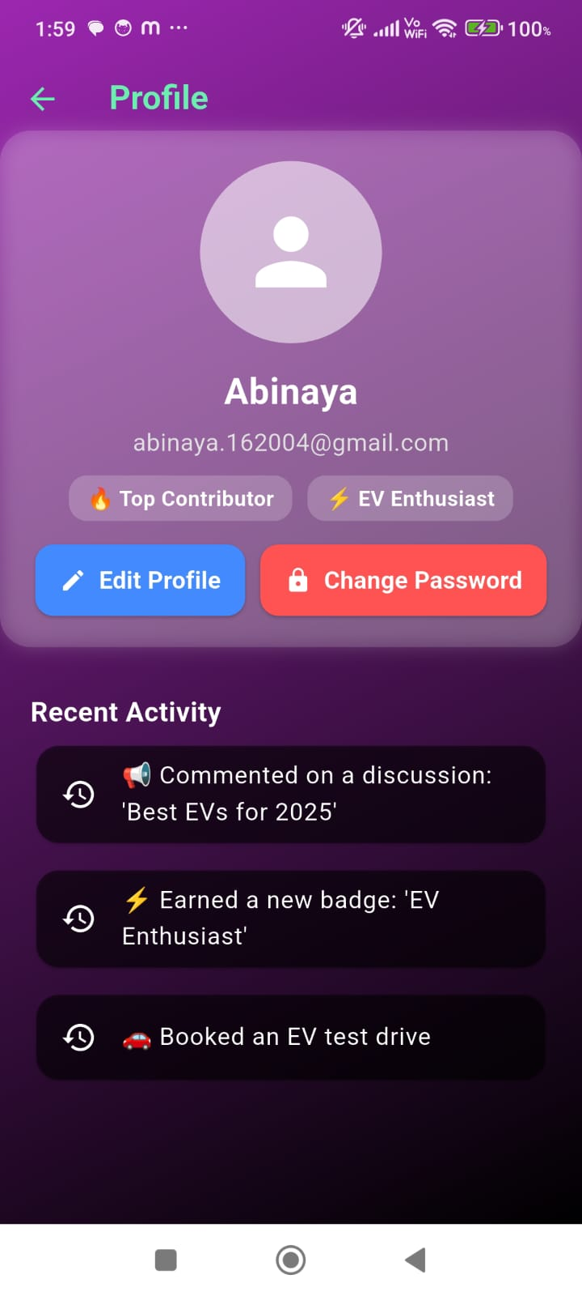

* **Contact & Support [Contact Icon]**

**Get in touch with customer support for assistance.**

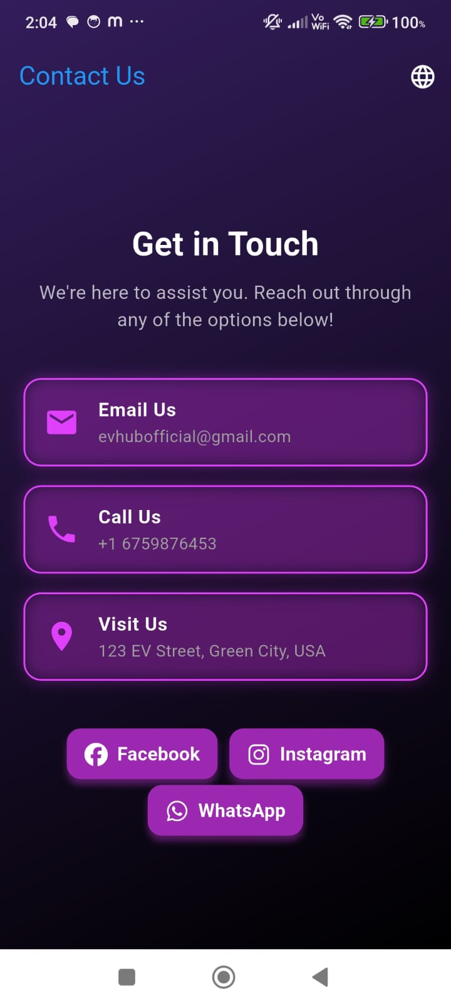

* **Theme Customization [Theme Icon]**

1. Customize themes for a personalized experience.
2. Tap ‘Sun’ to switch to Light Theme and ‘Moon’ for Dark Theme.
3. The Light Theme has a bright interface, while the Dark Theme offers a comfortable low-light experience.

**LightTheme [same pages that appears in light theme]**

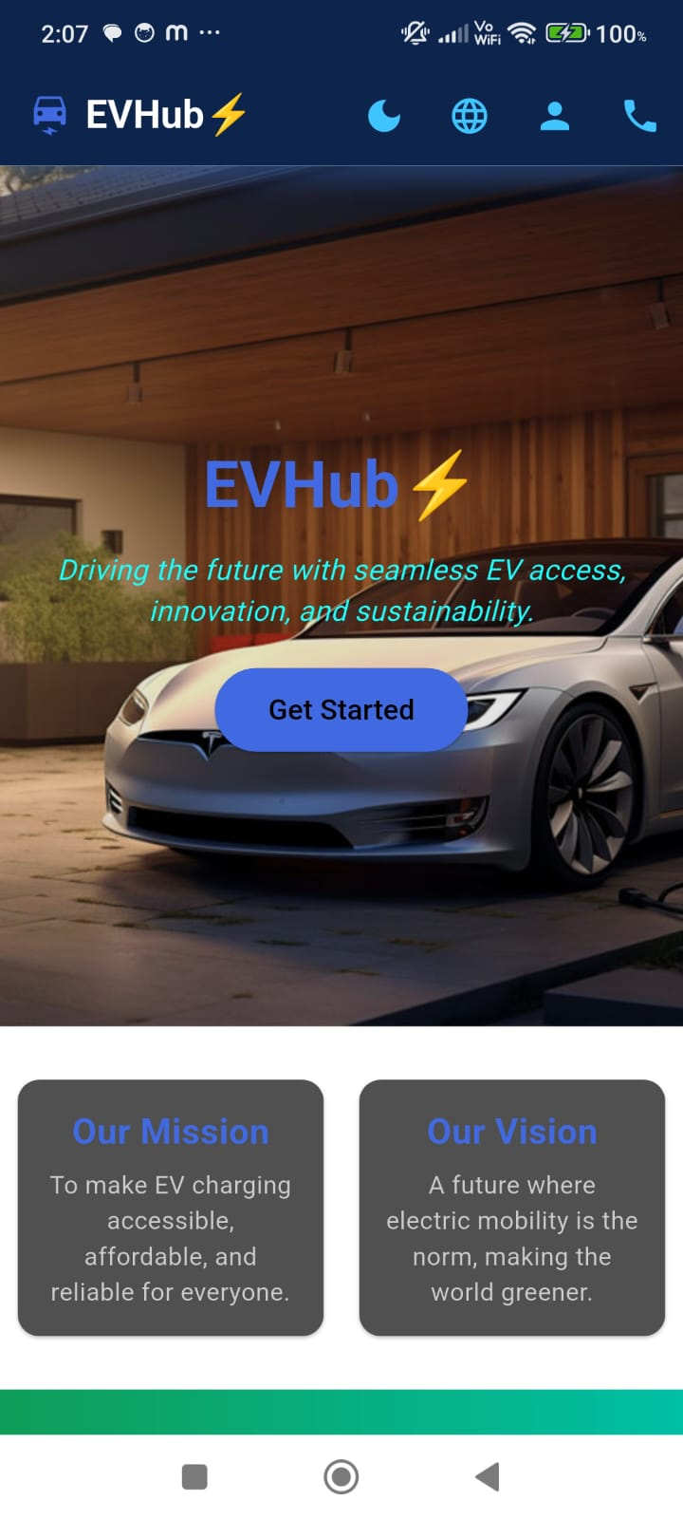



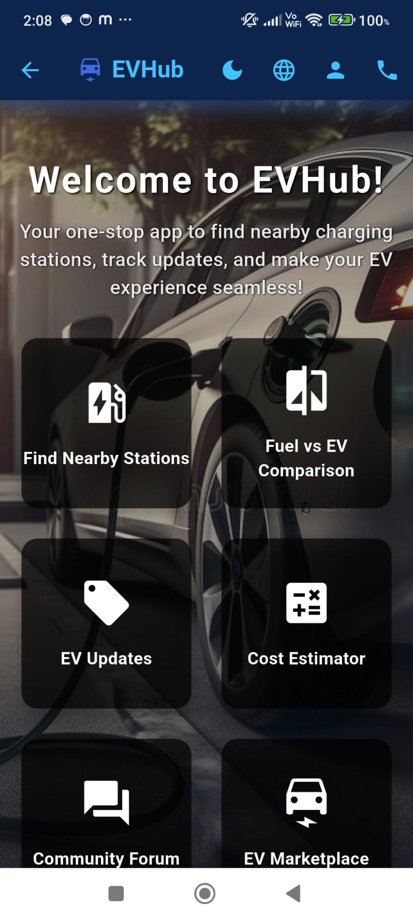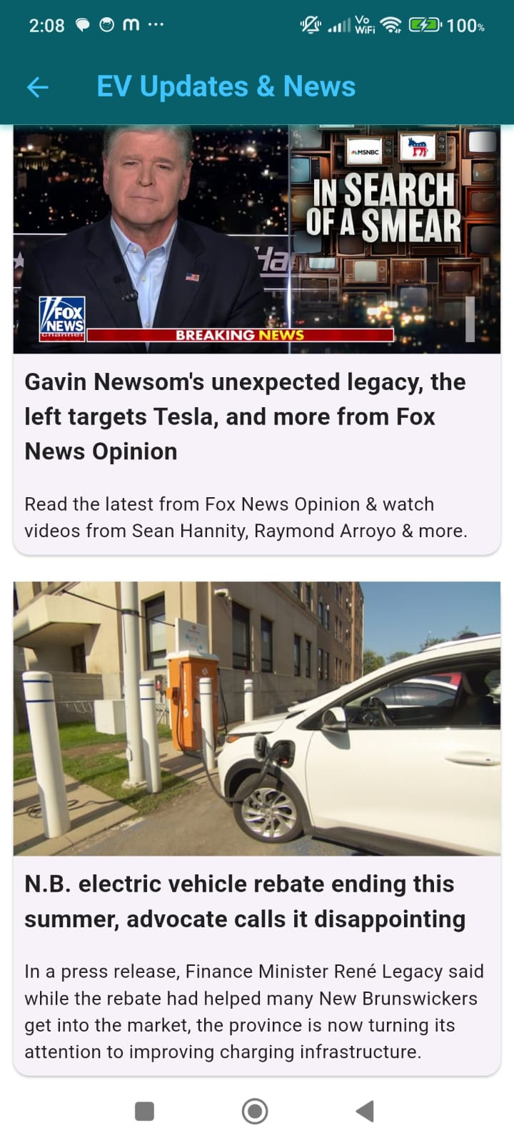

* **Language Support [language Icon]**

**Multiple language support for a global user experience.**

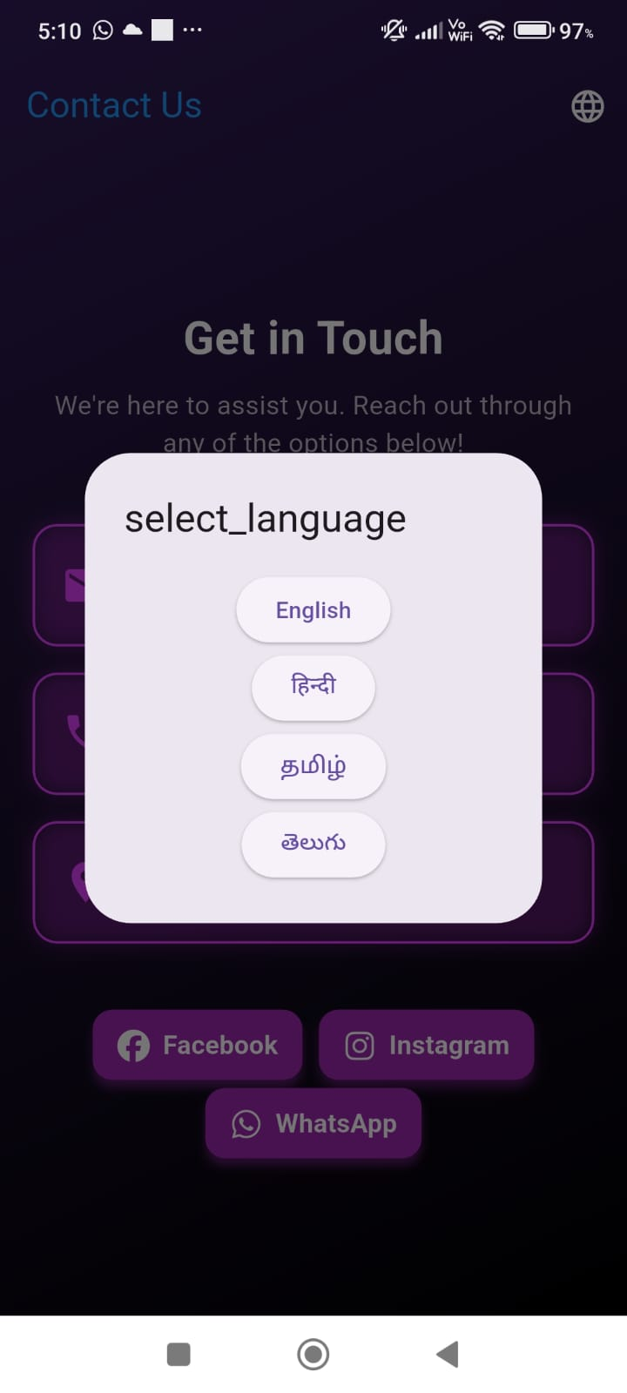

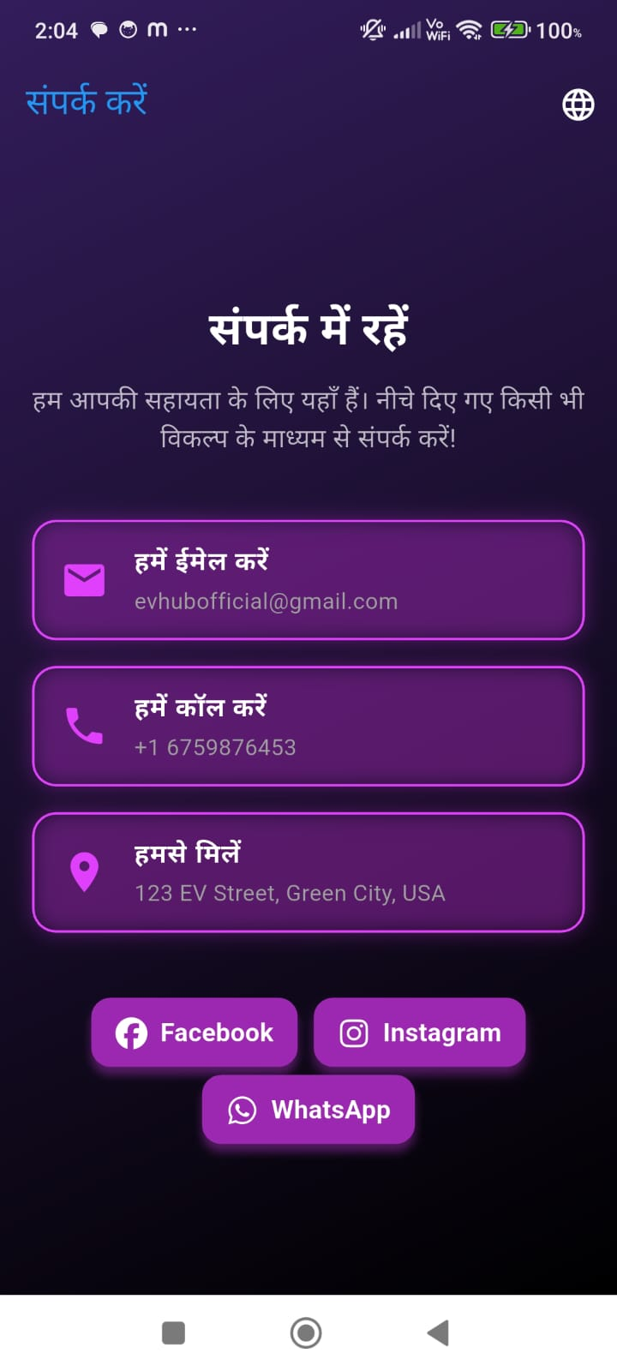

**Technology Stack & Key Features**

* Latest EV Updates: Displays news and updates on electric vehicles.
* Charging Station Locator: Search for nearby charging stations with map navigation.
* EV Marketplace: Buy, sell, and explore electric vehicles and related products.
* Cost Estimation: Estimate the total cost of owning an EV.
* Fuel vs Electric Comparison: Compare electric vehicles with fuel-powered cars.
* Firebase Authentication: Secure user registration and login.
* Community Forum: Connect with EV enthusiasts and share experiences.
* Dark/Light Theme: Option to switch between dark and light modes.
* Language Support: Multiple language options for a personalized experience.
* Profile Management: Manage user profile and preferences.
* Contact Support: Reach out for support, feedback, or inquiries.

**CONCLUSION:**

EVHub serves as a comprehensive platform for discovering, comparing, and purchasing electric vehicles, ensuring users have access to real-time listings, key specifications, and seamless navigation. By leveraging dynamic loading, secure API integration, and an intuitive UI, EVHub enhances the EV buying experience while promoting sustainable mobility.